AI-Assistant Assignment-9.1
2303A52335
Batch-44
Problem 1:
Consider the following Python function:
def find_max(numbers):
return max(numbers)
Prompt
Write a Python function that finds the maximum number from a list of numbers using the built-in max() function.
Document the function using three documentation styles: docstring, inline comments, and Google-style documentation. Then compare the three styles and explain which one is best for a mathematical utilities library.
Task:
• Write documentation for the function in all three formats:
(a) Docstring
(b) Inline comments
(c) Google-style documentation
• Critically compare the three approaches. Discuss the
advantages, disadvantages, and suitable use cases of each style.
• Recommend which documentation style is most effective
for a mathematical utilities library and justify your answer
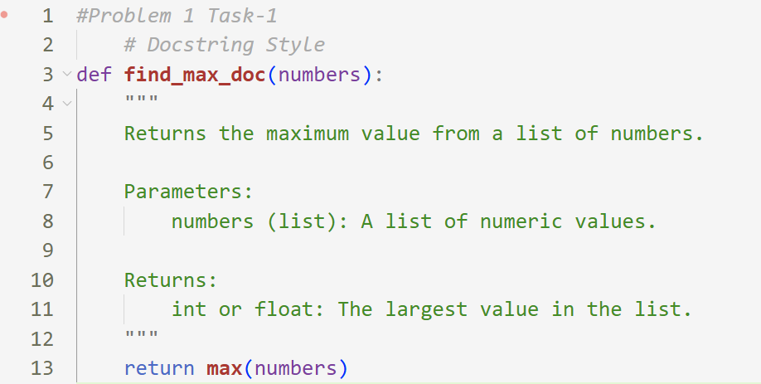
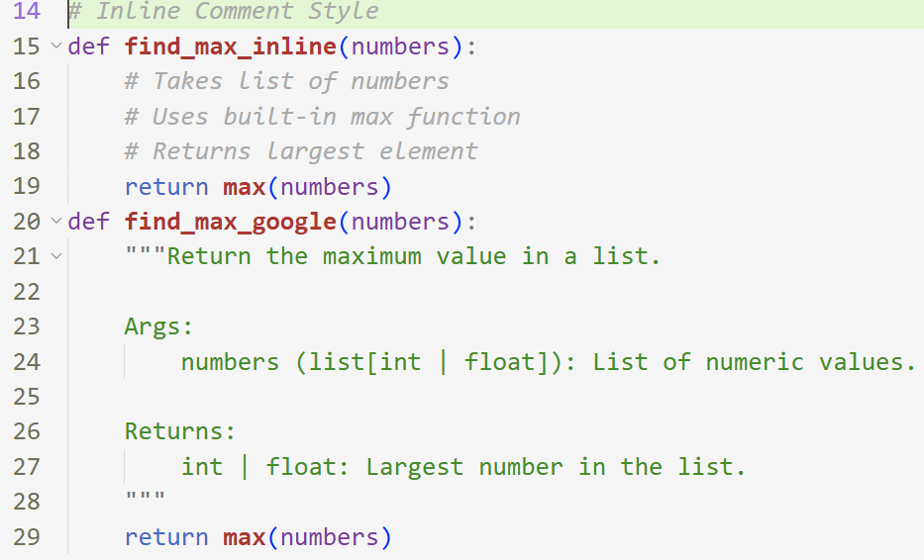
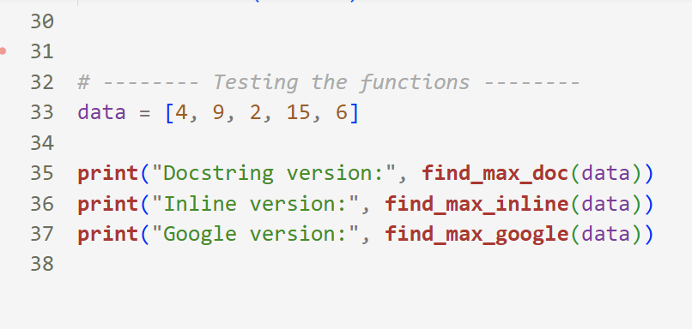
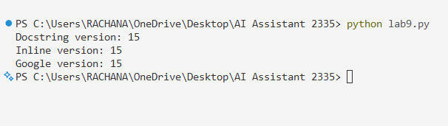
Description :
This task is about writing a Python function that finds the maximum number in a list and documenting it in three different styles: docstring, inline comments, and Google-style. It shows how documentation helps others understand what the function does, what input it needs, and what it returns. Among these, Google-style documentation is more clear and structured, so it is best for mathematical utility libraries.
Problem 2: Consider the following Python function:
def login(user, password, credentials):
return credentials.get(user) == password
Task:
1. Write documentation in all three formats.
2. Critically compare the approaches.
3. Recommend which style would be most helpful for new
developers onboarding a project, and justify your choice.
Prompt :
Write a Python function to check whether a user login is valid by comparing the given username and password with stored credentials in a dictionary. Document the function using docstring, inline comments, and Google-style documentation, then compare which style is best for new developers.
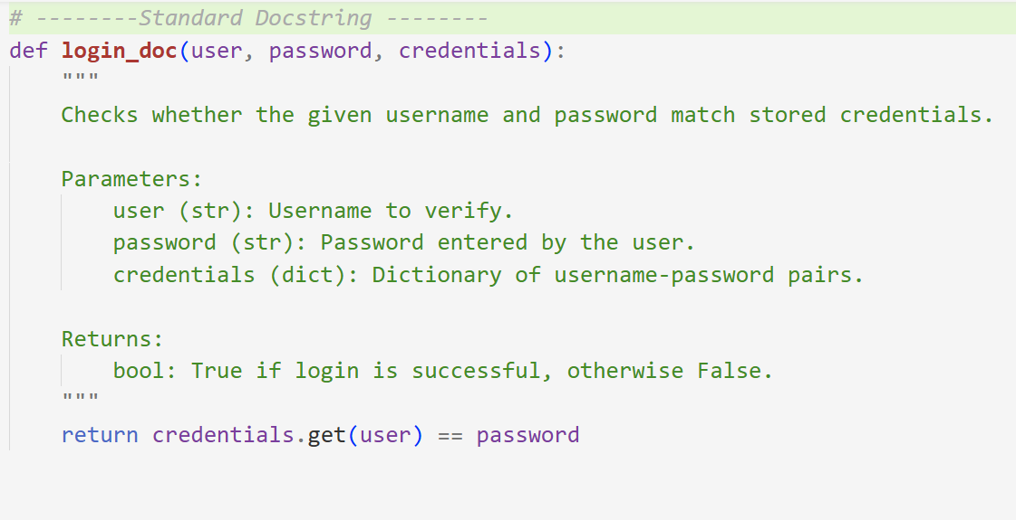
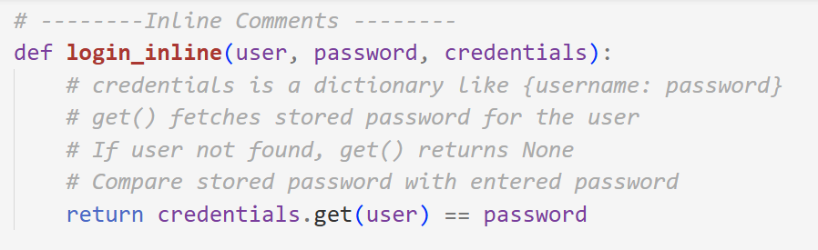
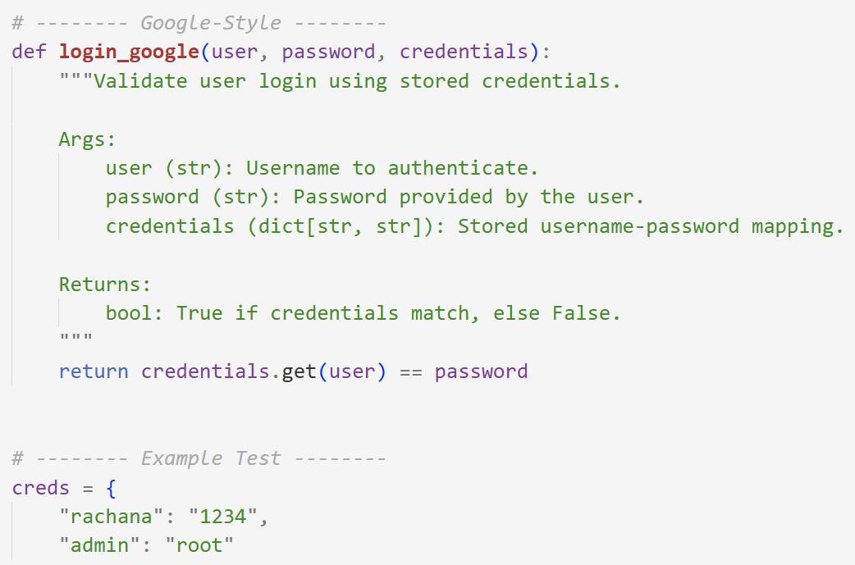
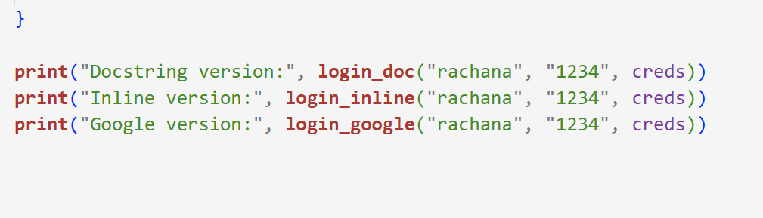
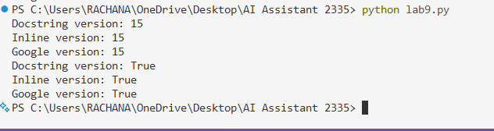
Description
This problem is about creating a login verification function that checks if the entered password matches the stored password for a given user. The main goal is to show how the same function can be documented in three different documentation styles. This helps understand how proper documentation makes code easier to read and maintain, especially for new developers joining a project.
Problem 3: Calculator (Automatic Documentation Generation)
Task: Design a Python module named calculator.py and
demonstrate automatic documentation generation.
Instructions:
1. Create a Python module calculator.py that includes the
following functions, each written with appropriate docstrings:
o add(a, b) – returns the sum of two numbers
o subtract(a, b) – returns the difference of two numbers
o multiply(a, b) – returns the product of two numbers
o divide(a, b) – returns the quotient of two numbers
2. Display the module documentation in the terminal using
Python’s documentation tools.
3. Generate and export the module documentation in HTML
format using the pydoc utility, and open the generated HTML
file in a web browser to verify the output.
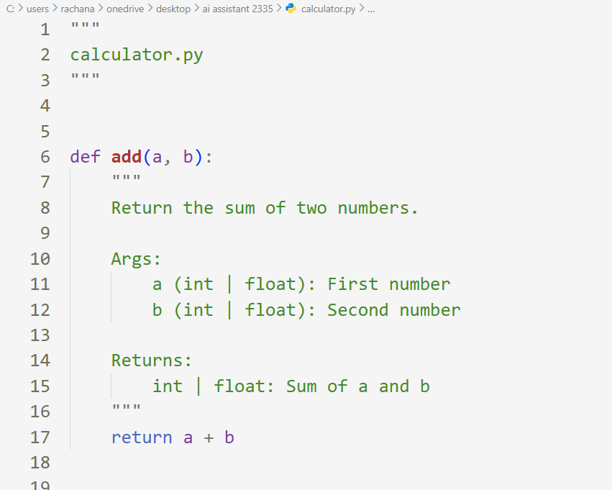
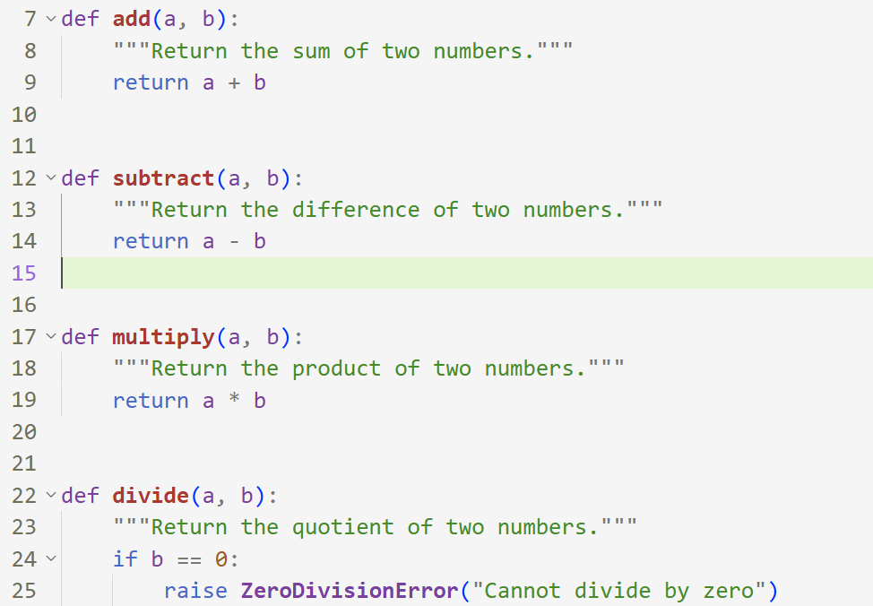
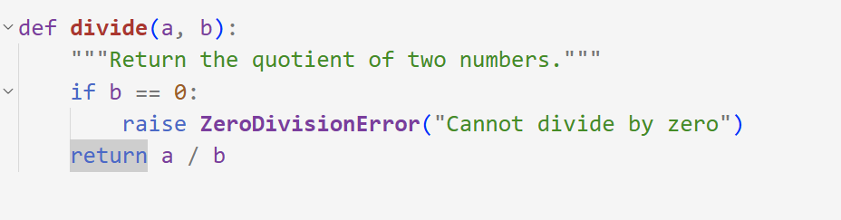
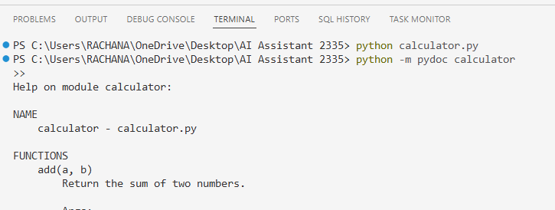
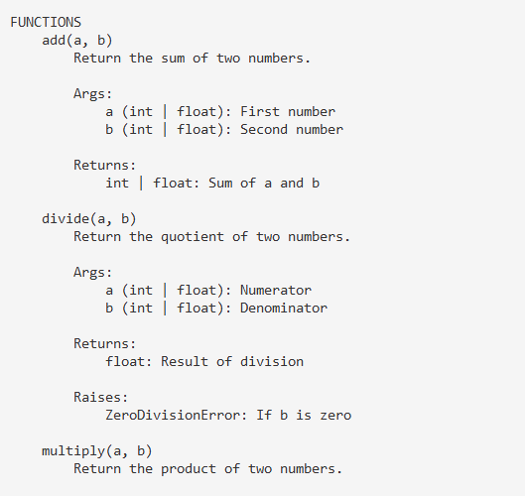
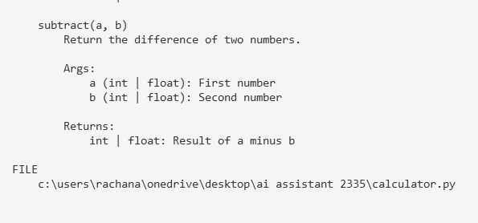
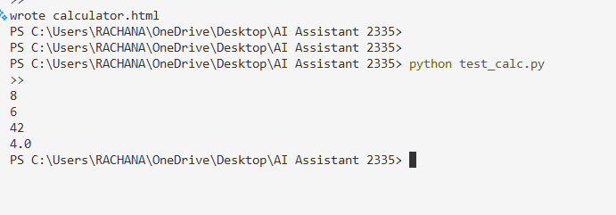
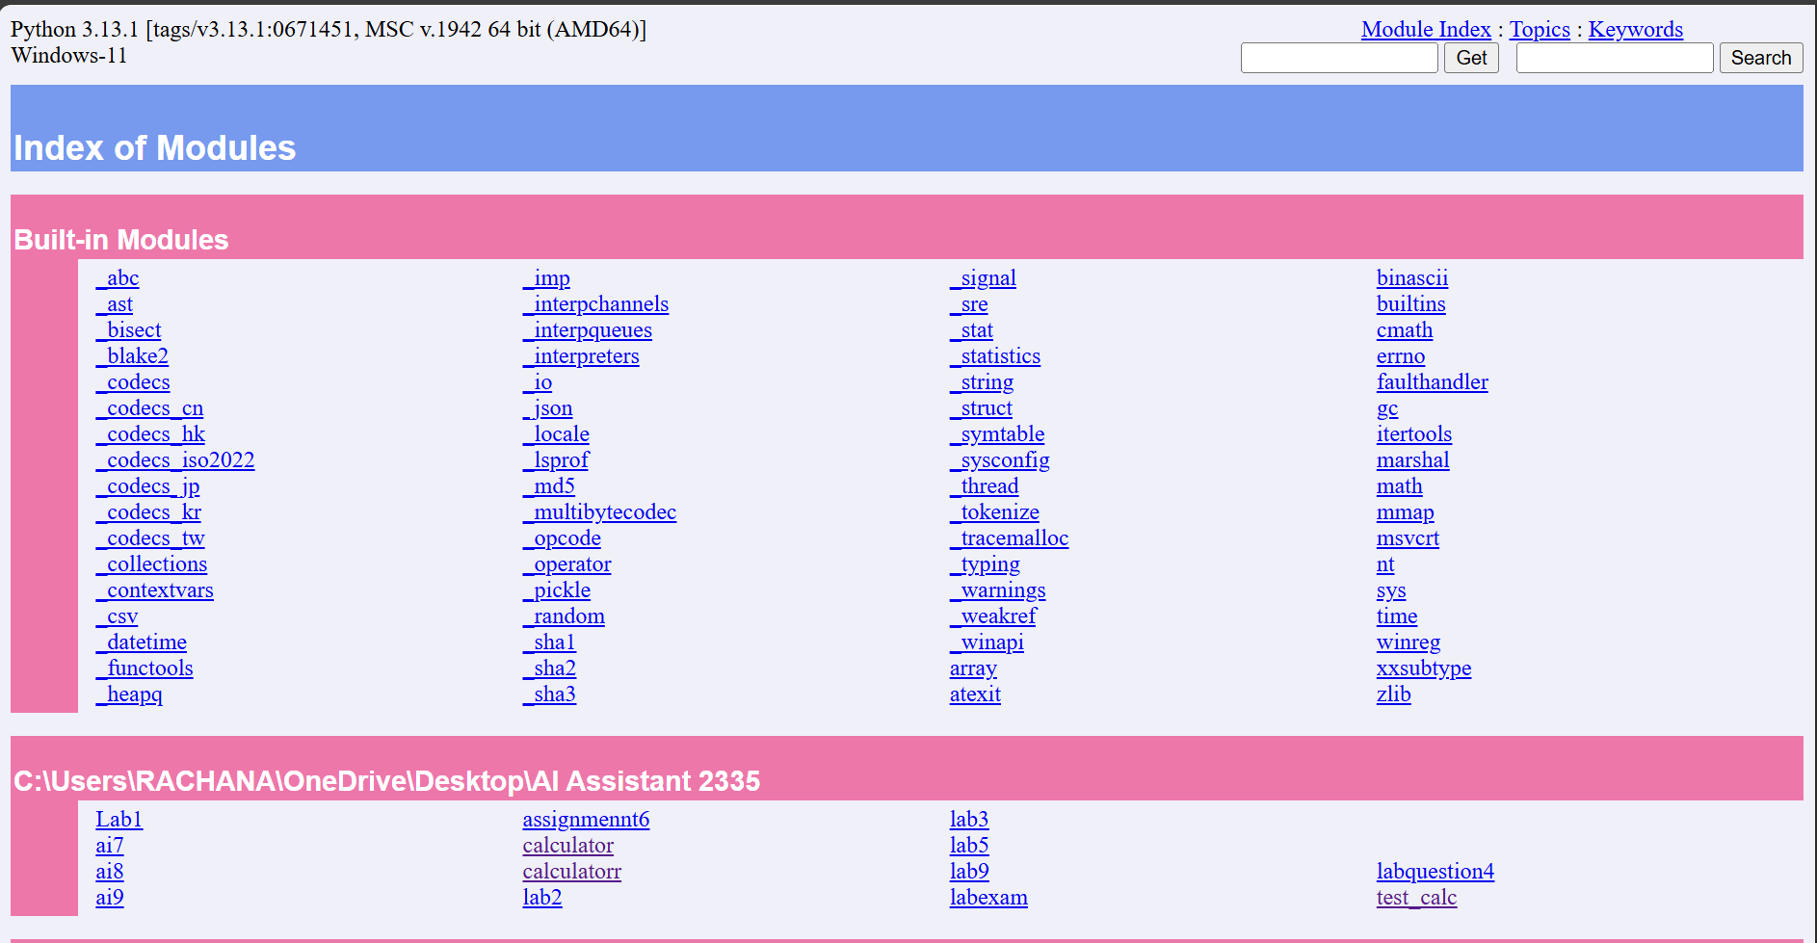
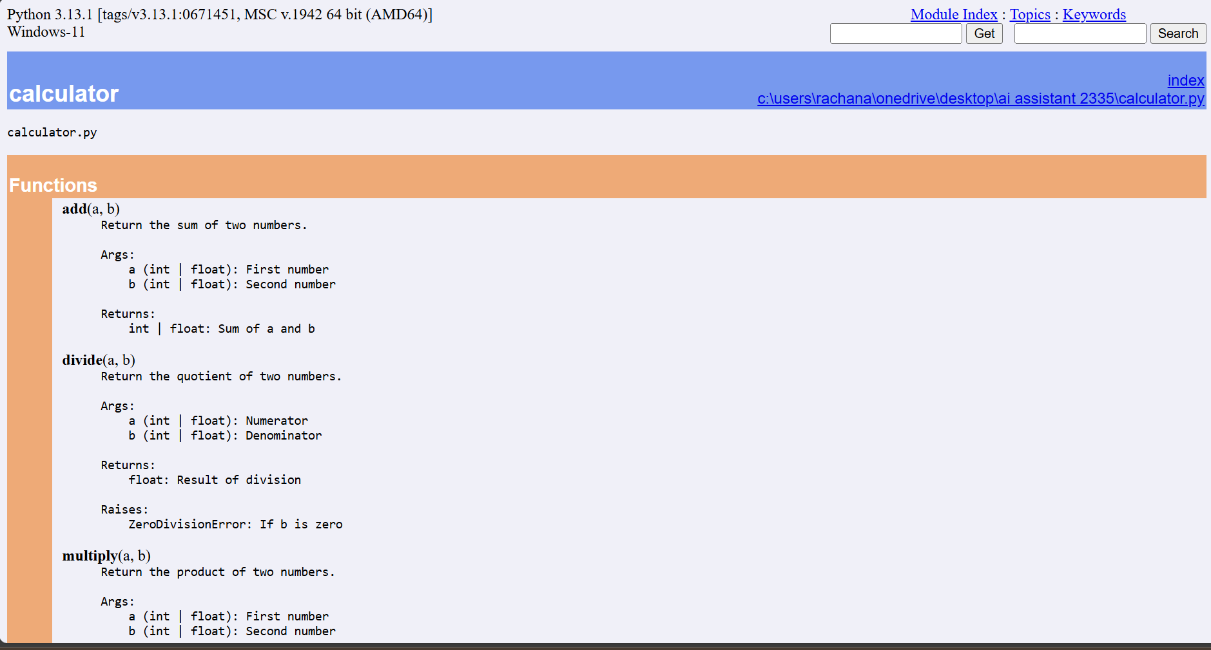
Result:
The calculator.py module was created with proper docstrings. Using the pydoc tool, automatic documentation was generated and displayed in a web browser. All arithmetic functions (add, subtract, multiply, divide) appeared correctly in the generated documentation.
Problem 4: Conversion Utilities Module
Task:
1. Write a module named conversion.py with functions:
o decimal_to_binary(n)
o binary_to_decimal(b)
o decimal_to_hexadecimal(n)
2. Use Copilot for auto-generating docstrings.
3. Generate documentation in the terminal.
4. Export the documentation in HTML format and open it in a
browser.
Prompt Used:
“Generate Python conversion utility functions with structured docstrings for decimal–binary–hexadecimal conversions.”
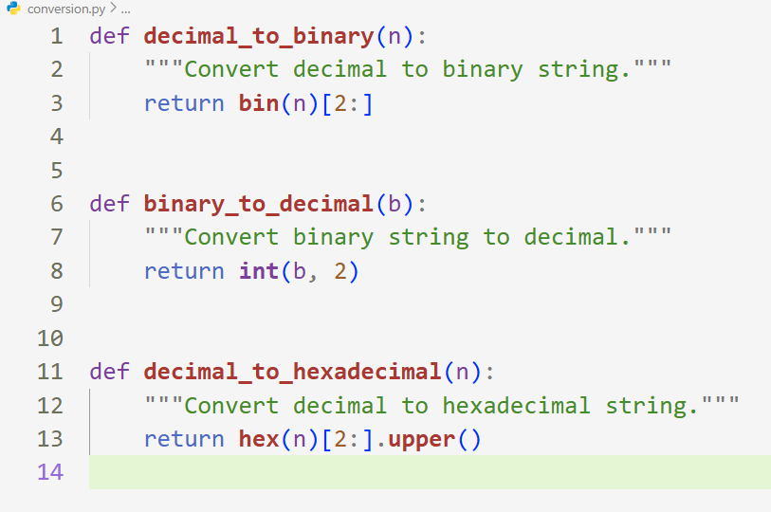
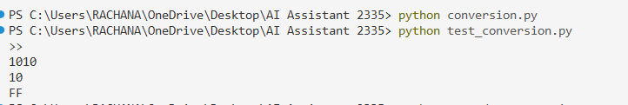
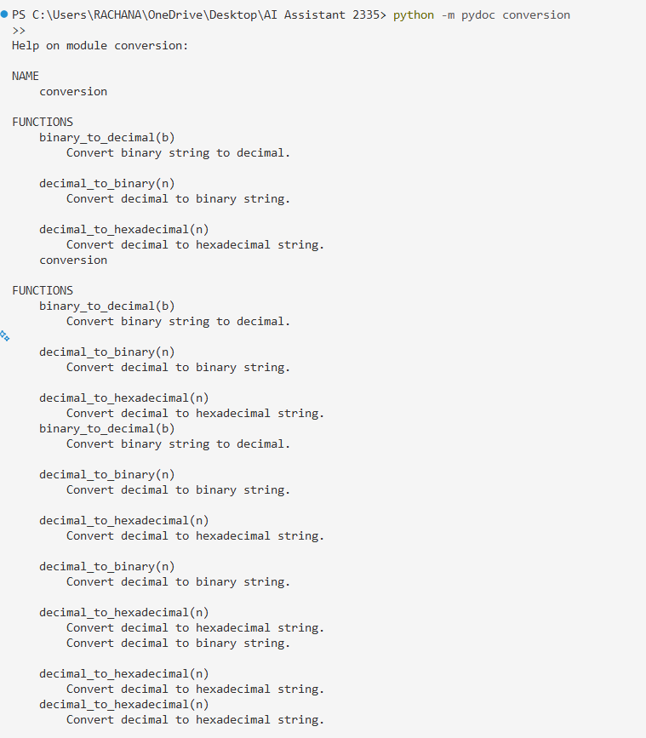
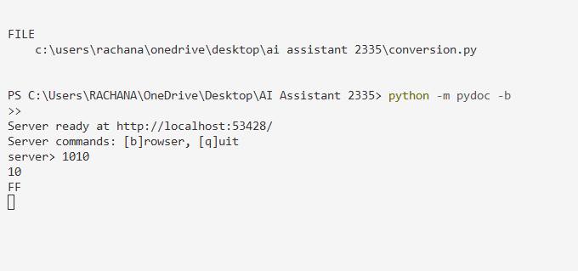
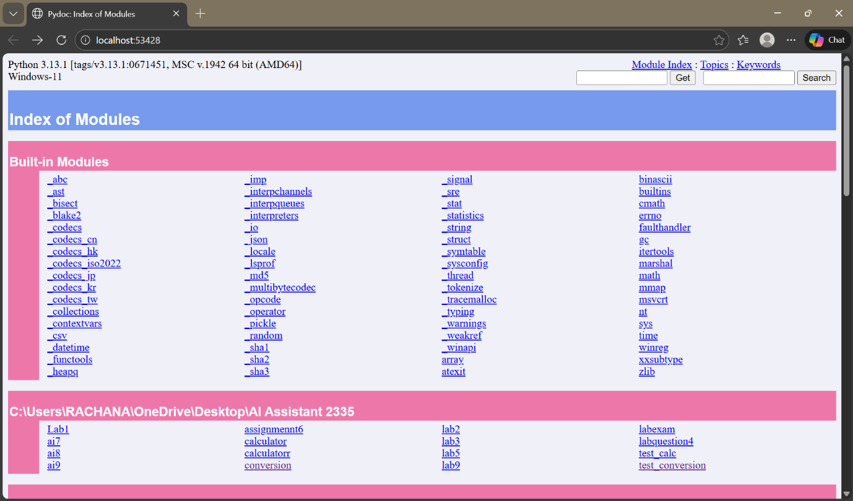
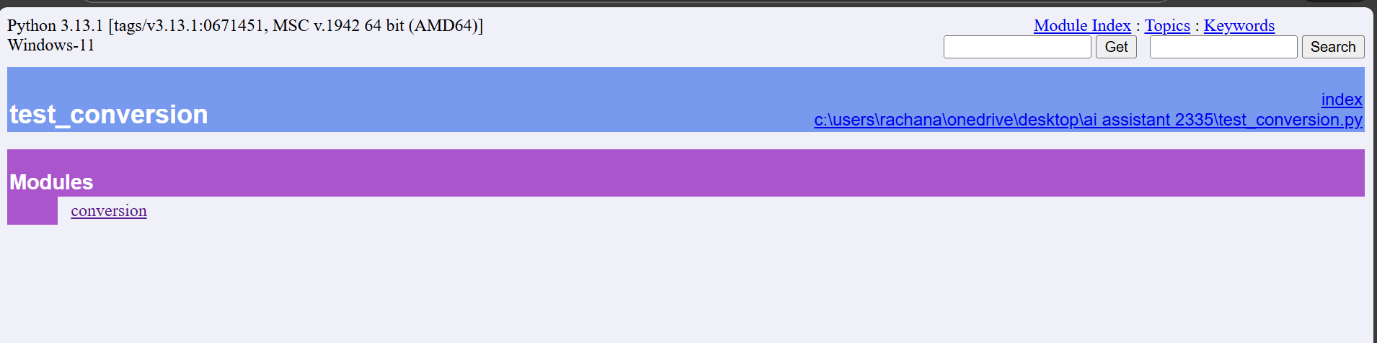
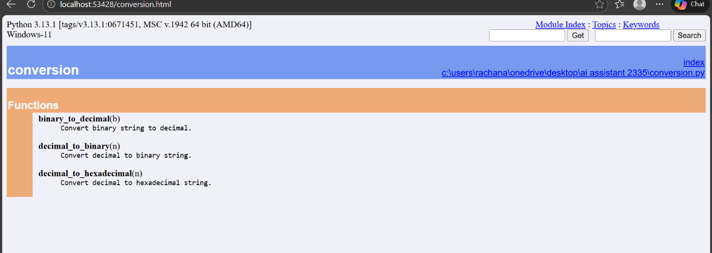
Description:
The conversion.py module provides utility functions for converting numbers between different number systems. It supports conversion from decimal to binary, binary to decimal, and decimal to hexadecimal. The module is designed with clear docstrings so that automatic documentation tools like pydoc can generate structured terminal and HTML documentation.
Problem 5 – Course Management Module
Task:
1. Create a module course.py with functions:
o add_course(course_id, name, credits)
o remove_course(course_id)
o get_course(course_id)
2. Add docstrings with Copilot.
3. Generate documentation in the terminal.
4. Export the documentation in HTML format and open it in a
browser.
Prompt Used:
“Generate Python course management functions with structured docstrings for add, remove, and retrieve operations.”
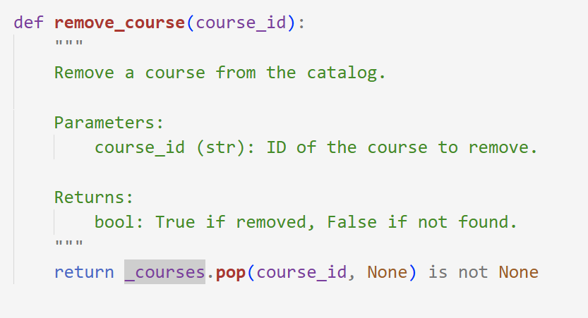
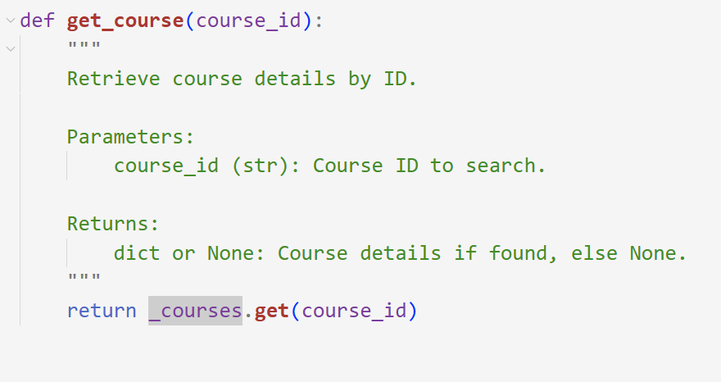
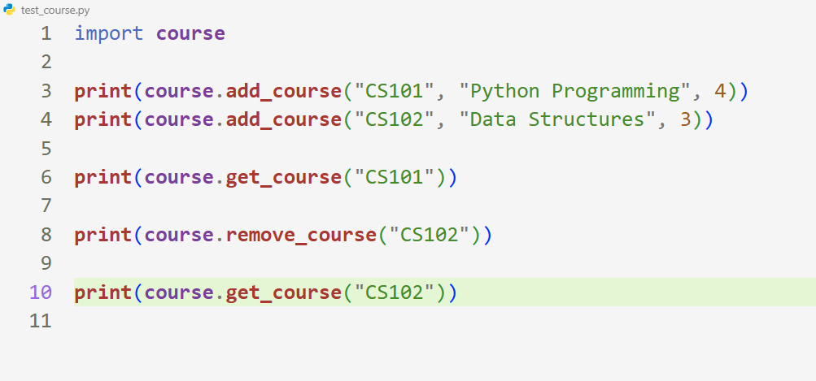
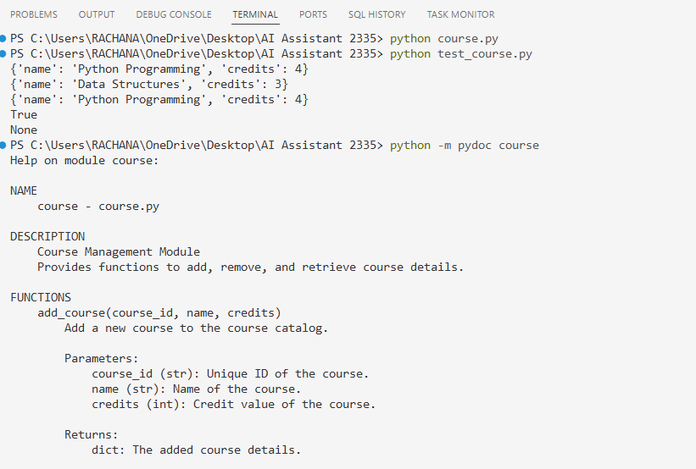
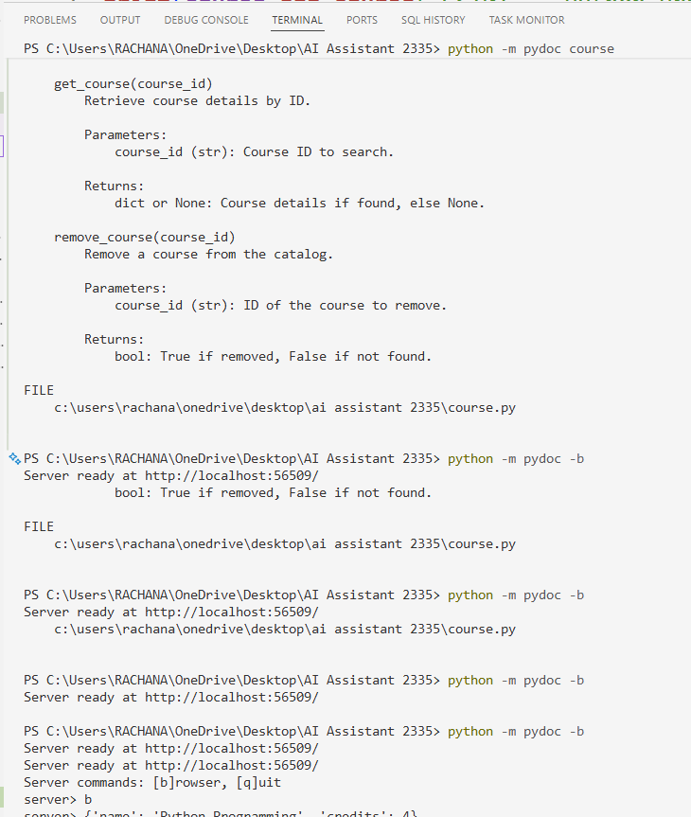
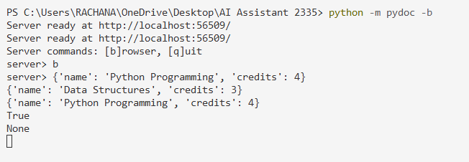
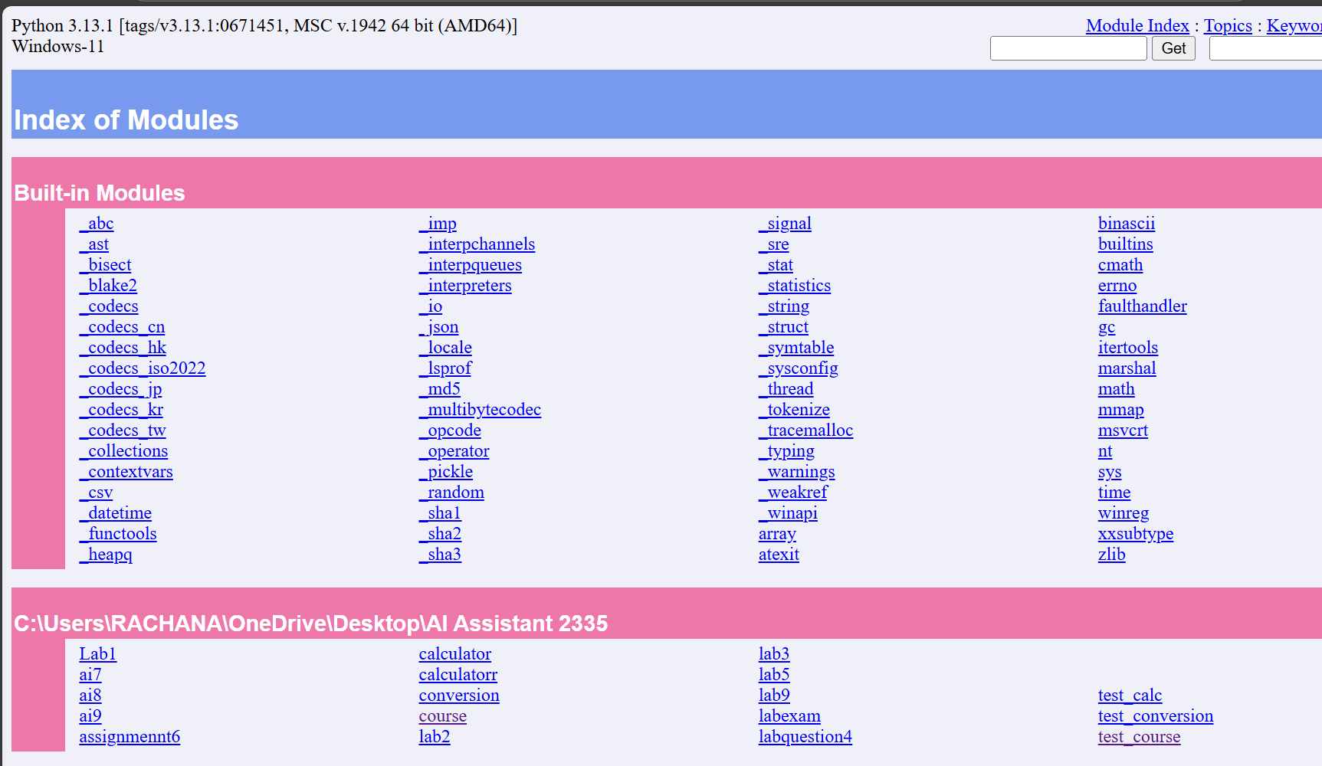
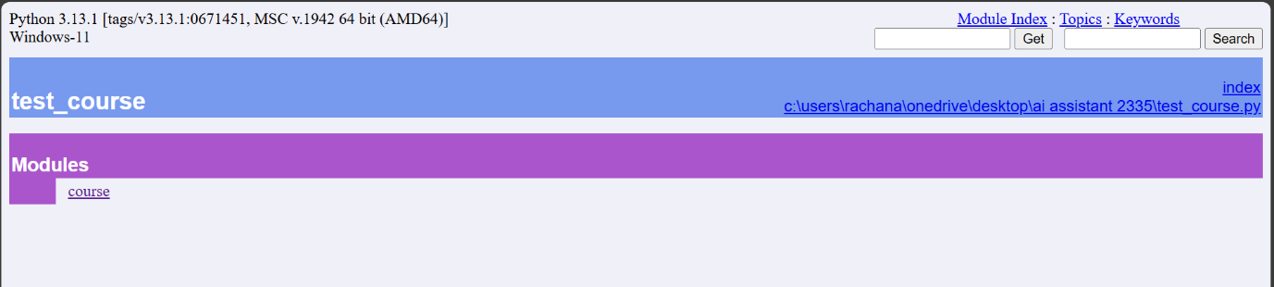
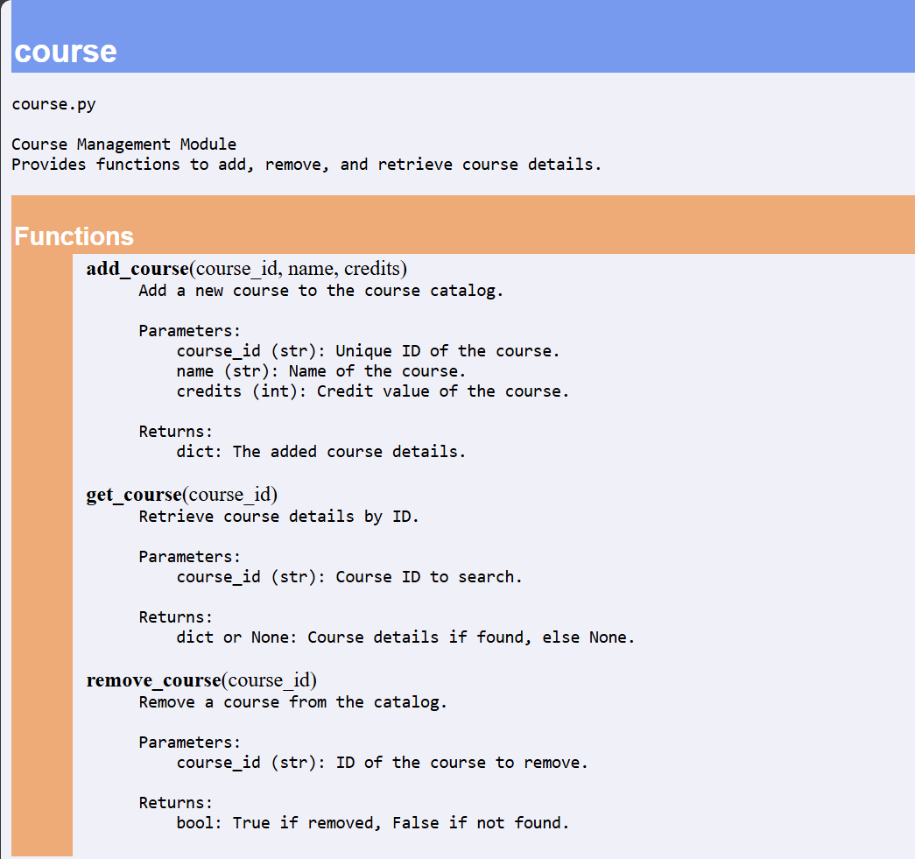
Description:
The course.py module is a Course Management utility that allows adding, removing, and retrieving course details using unique course IDs. It stores course data such as course name and credits in an internal dictionary. Each function is documented with structured docstrings so that automatic documentation tools like pydoc can generate terminal and HTML documentation. GitHub Copilot can be used to auto-generate these docstrings and improve documentation quality.

